1. In the current directory is creates a subdirectory named *TopDir* and displays a message

**created TopDir**

2. In *TopDir* it creates a subdirectory named *BottomDir* and displays a message

**created TopDir/BottomDir**

3. Then it changes the current directory to *TopDir*/*BottomDir* and displays a message

**current directory is TopDir/BottomDir**

4. In *BottomDir* it creates 19 ASCII text files named **File2, ..., File20**. The content of File2 consists of two lines: the first saying

**My name is File 2**

and the second saying

**Next file's name will be File3**

The content of File3 consists of two lines

**My name is File3**

and

**Next file's name will be File4**

etc. The last created file File20 contains two lines, the first saying

**My name is File 20**

and the second saying

**No next file**

5. Every time a file is created, a message

**created file xxx**

where xxx is the file being created is displayed.

6. Then it displays a message

**contents of all files in BottomDir**

and then for each file of BottomDir it displays its name followed by a colon and all the lines of the contents of the file followed by a line consisting of dashes (see the sample below).

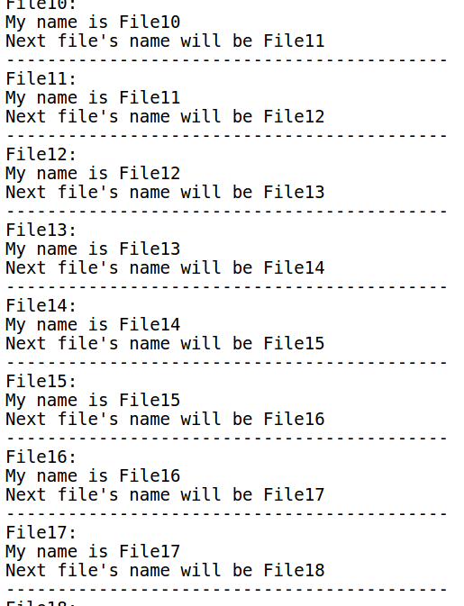ex.

7. Then it moves all files containing a character 0 or a character 2 or a character 3 from *BottomDir* to *TopDir*.

8. Displays a message

**listing all files of TopDir**

and then it displays names of all files in *TopDir*.

9. Then it displays a message

**listing all files of BottomDir**

and then it displays names of all files in *BottomDir*.

10. Then it creates a single file in *TopDir* named SuperFile that contains all the lines from all the files in *TopDir*.

11. Removes all other regular files from *TopDir* except SuperFile.

12. Displays

**listing all files of TopDir**

and then displays names of all files in *TopDir*.

13. Displays

**the content of SuperFile:**

and then displays all the lines of SuperFile.

14. Then it changes the permissions for all regular files in *BottomDir* so that all files are readable by all, executable by owner+group and writeable by owner only.

